IEEE 802.11 Wireless Fidelity (WİFİ)

1. Also known as Wireless Fidelity (wifi)
2. Like its Ethernet and token ring siblings, 802.11 designed for use in a limited geogrraphical area (homes, office, campuses)
3. Primary challenge is to mediate access to a shared communication medium – in this case, signals propagating through space.
4. 802.11 supports additional features:
   1. Power management
   2. Security mechanisms

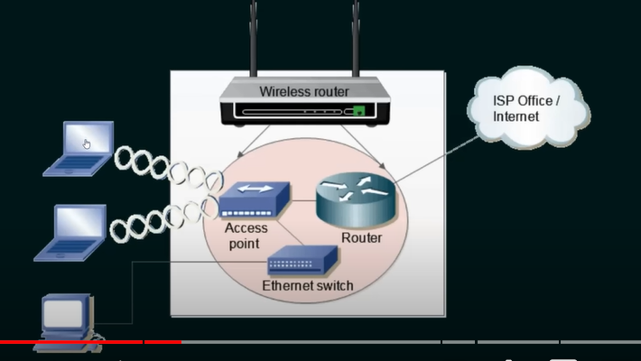

Wireles router replaceses access point, router, ethernet switch.

How wifi works?

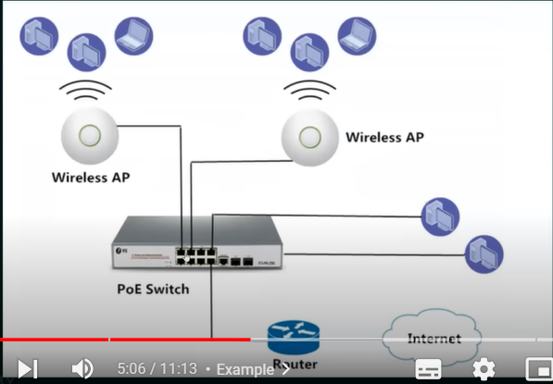

1. 802.11 uses 5 GHz Raido Band (high frequency) which has 23 overlapping channels rather than the 2.4 GHz frequency band which has only three non-pverlapping channels
2. Acces method of IEEE 802.11 wifi: CSMA/CA (Collision avoidance) → it cannot collision detect since signals are send to main place.

Adapters:

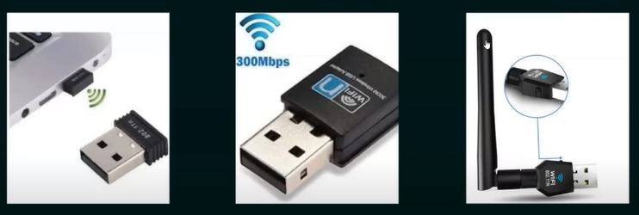

**Modes of Wifi:**

1. Infrastructure mode:

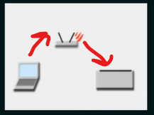 (No direct communication between devices. Central place that forwards the data)

1. Adhoc and wifi direct

**Different Wifi protocols**

